# 4COSC008C Trends in Computer Science

# Tutorial Week 4

**Task1**

Complete tasks from the week 3 tutorial, where appropriate.

# Task 2

Work on your presentation topic.

1. Identify keywords from your chosen presentation topic
2. Find up to 3 sources (a combination of a book, a journal article, a dictionary, encyclopaedia or handbook entry, or quality information on the Internet)
3. Construct the references for the sources you have found. Share one example with everyone in your group (via the chat).
4. Remember that your sources should have the form Surname, I(nitial). (date) Title Location: Publisher.
5. Based on the feedback you received from your first example, share with your tutor (via private chat) all three examples of sources you have identified.

# Task 3

Now consider the sources you have identified. Are they accurate? Credible? Current? Why will they be useful for your work?

Present orally your sources to the tutorial group and explain why these sources will be useful to your work (approximately 1 minute per student- rehearsal presentation).

# Task 4

Consider the CW1 marking scheme and discuss any questions you might have. Note that we will discuss the report during the week 5 tutorial.

# Task 5

In your opinion, what are the characteristics of a successful presentation?

Work on your presentation’s structure and share its draft structure with your tutor (via private chat or email).

# Beyond this tutorial, this is where to find ‘Referencing your Work’ booklet on the intranet.

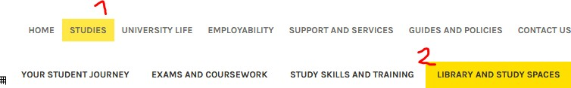

and then;

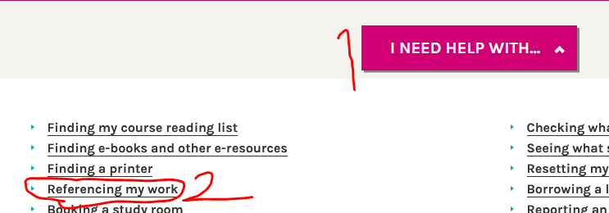

# 1- In text Citation examples

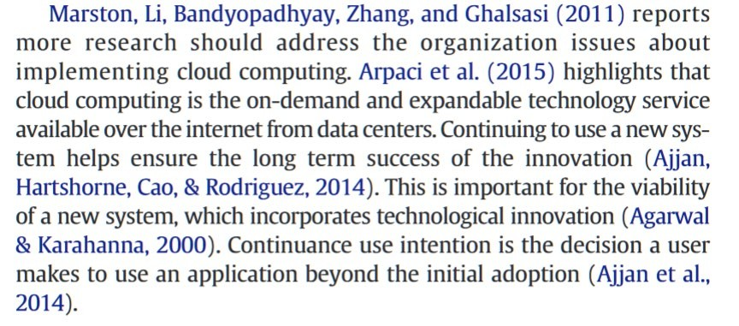

**Independent study**

Consider the following:

1. The British Computer Society Professional Code of Conduct http[s://www.bcs.org/membership/become-a-member/bcs-code-of-conduct/](http://www.bcs.org/membership/become-a-member/bcs-code-of-conduct/)
2. The information provided by the Information Commissioner’s Office on Data Protection. https://ico.org.uk/your-data-matters/